**Project: Online Jukebox + DOS attack using Selenium IDE + Python Web Server**

Download Selenium IDE for Chrome from this URL:

<https://chrome.google.com/webstore/detail/selenium-ide/mooikfkahbdckldjjndioackbalphokd?hl=en>

Let’s open terminal and start python server first:

python3 -m http.server --cgi

Then click extension on Chrome browser, you will see this:

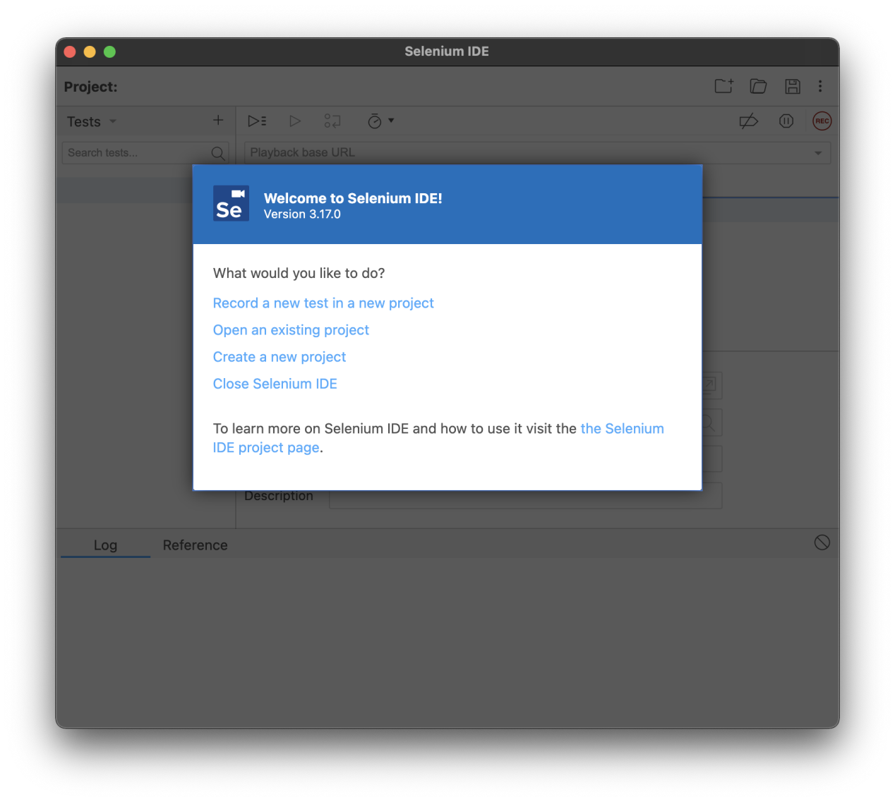

Let’s record a new project and name it “DOS-Attack”:

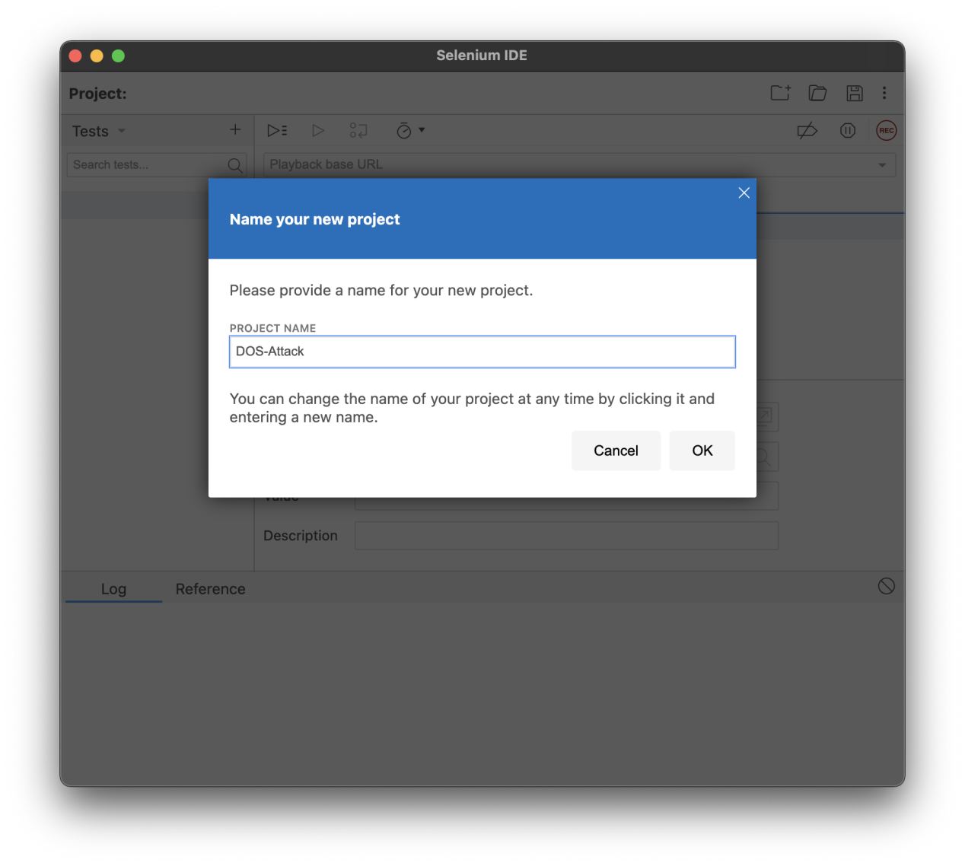

Next create a new test case:

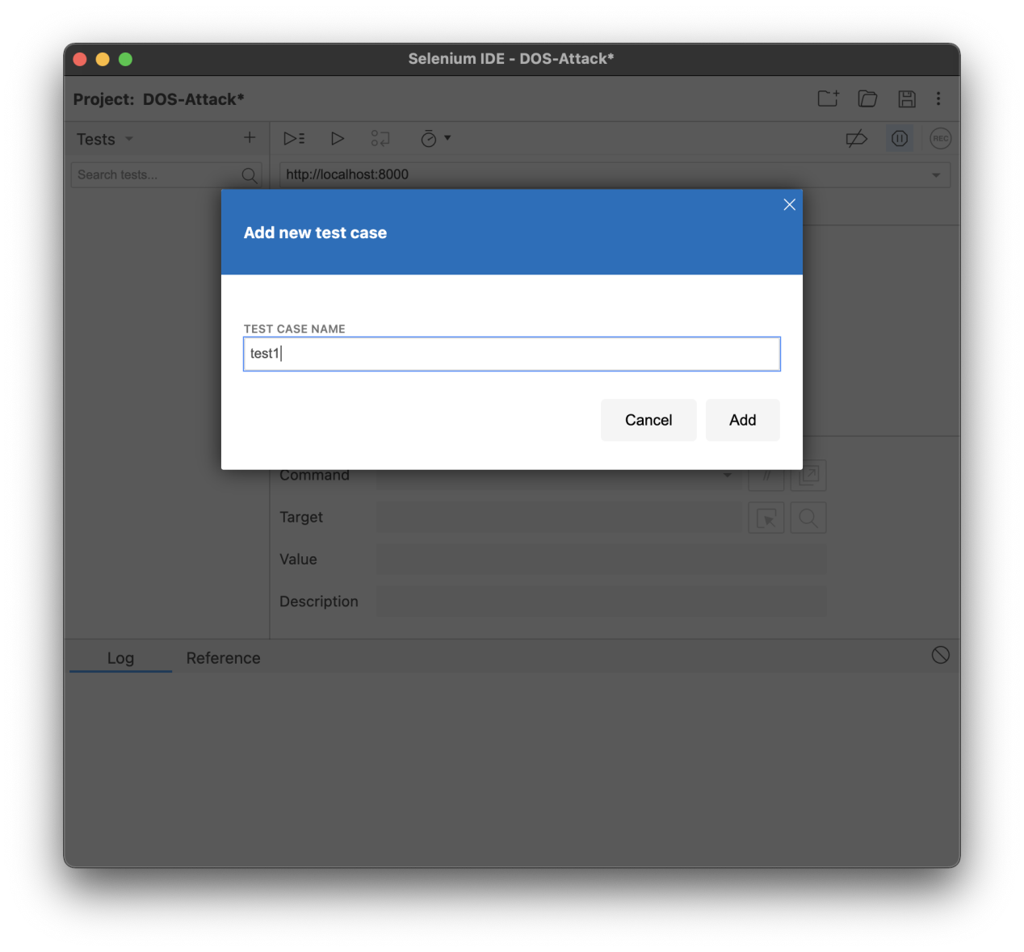

Next, it will ask you a test URL, in my case is “http://localhost:8000/jukebox_without_reCAPTCHA.html”

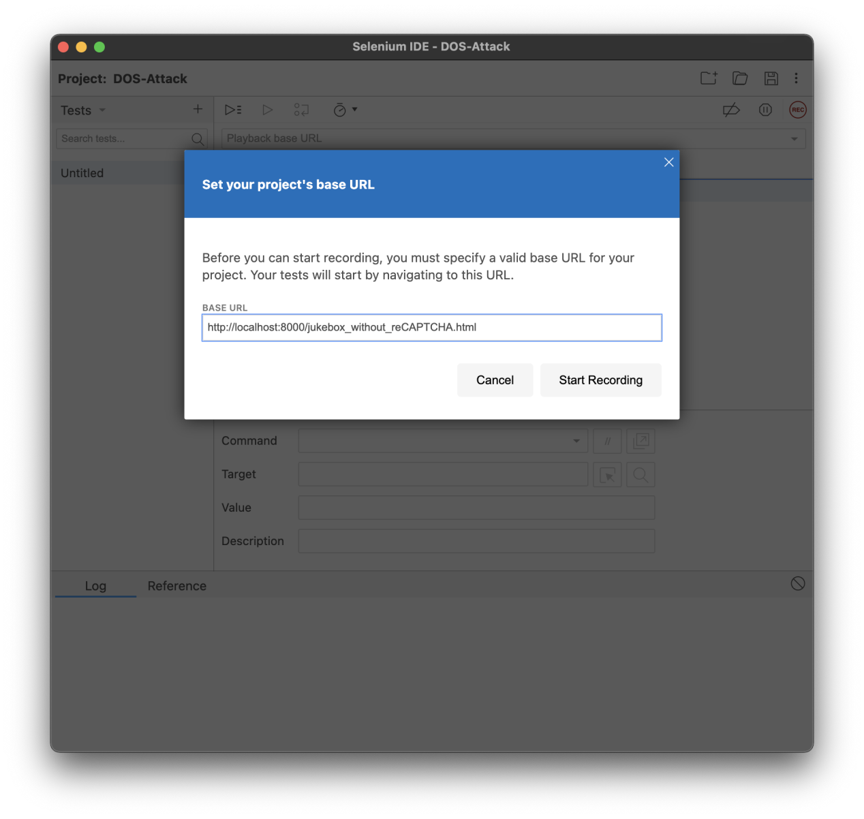

It will jump a new window like this, on the right corner it says Selenium IDE is recording... 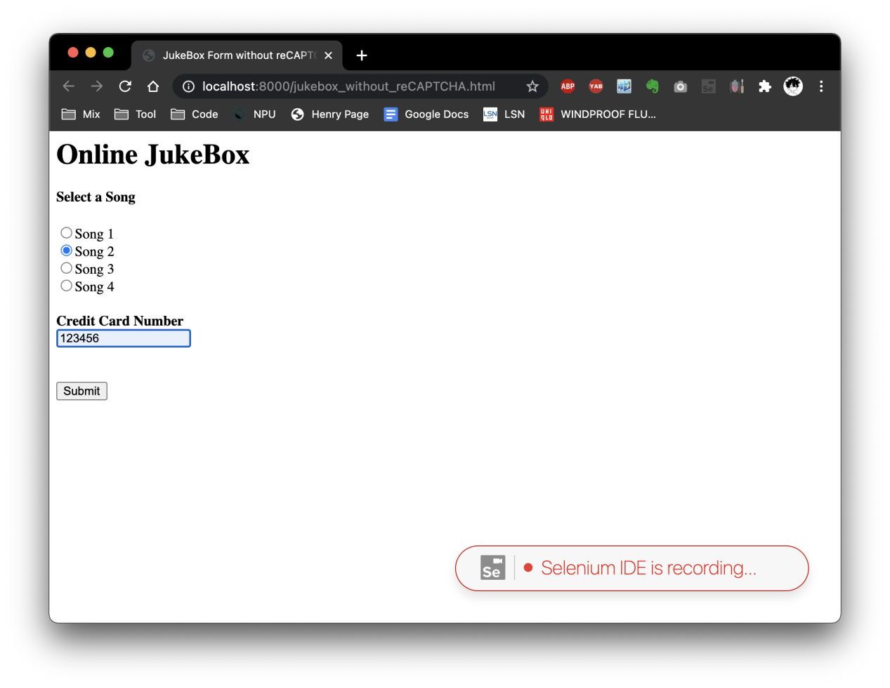

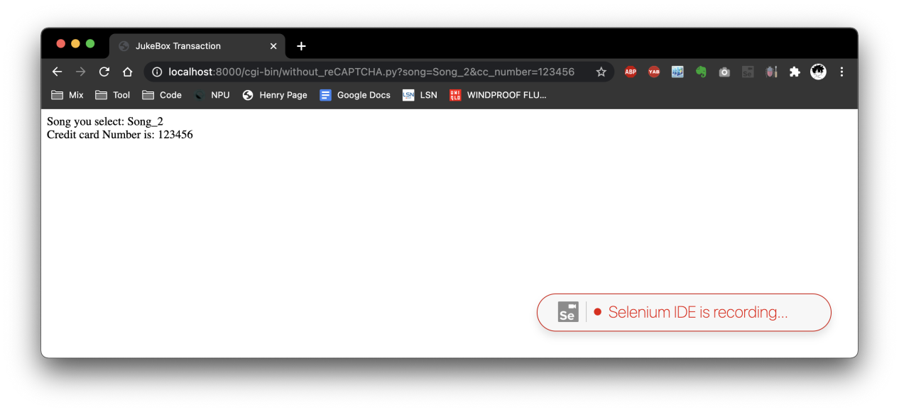

Go back to Selenium IDE extension to stop recording.

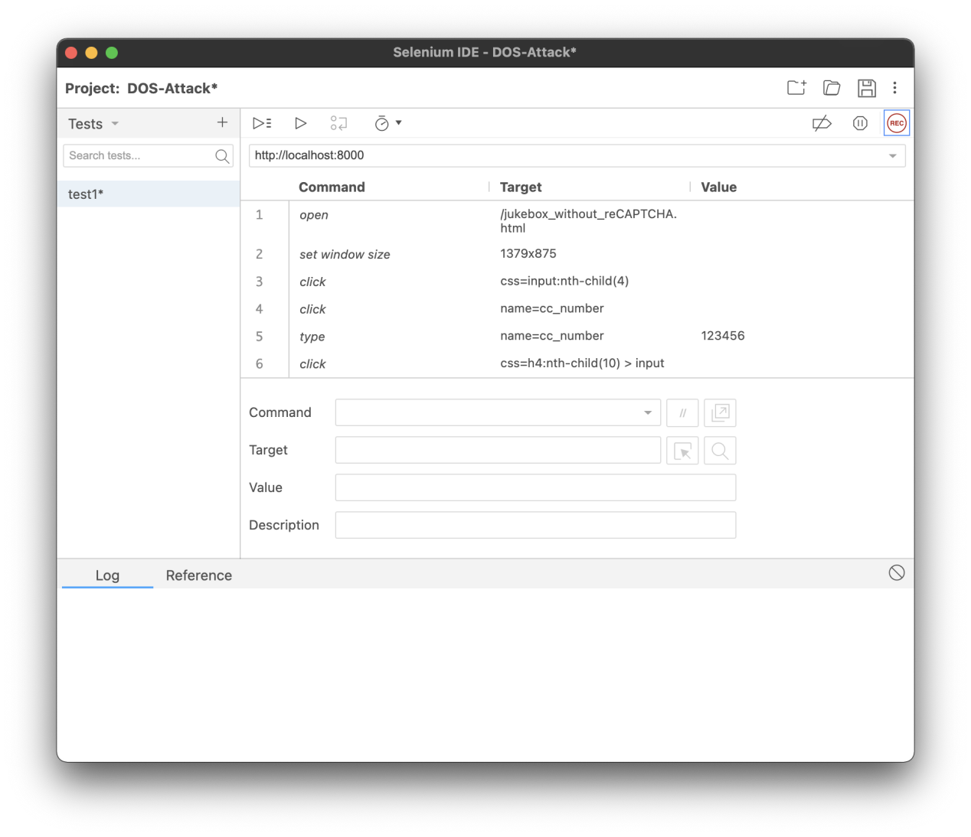

You will see something like this which is your click steps.

Now click “Run test” to replay your click on your page. 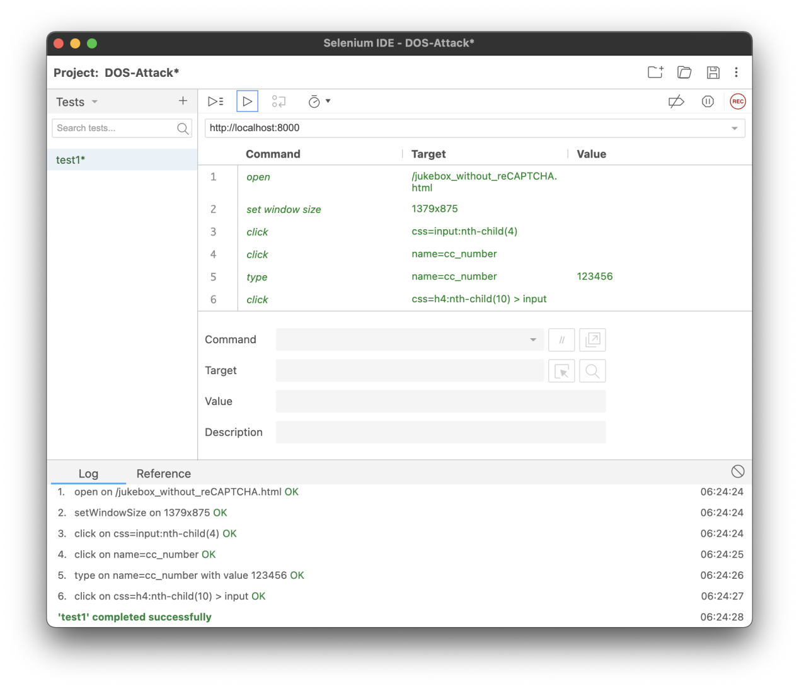

After we run test case several times, we can see that database adds 4 records due to our DOS attack by using Selenium.

